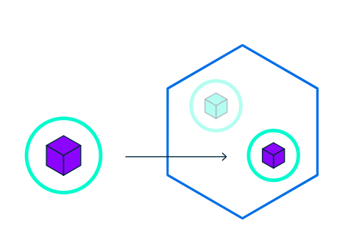

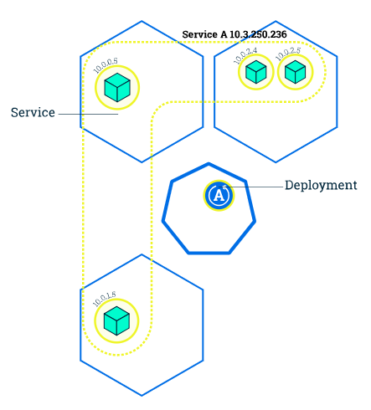

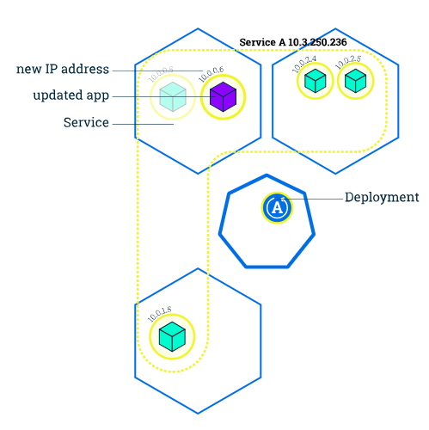

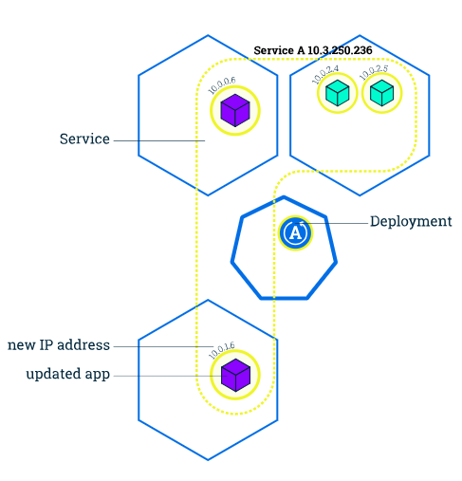

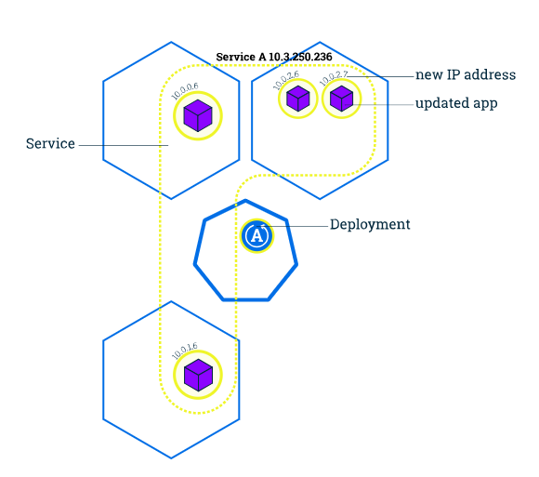

The diagrams are self-explanatory. **Rolling updates**allows Deployments to occur with zero downtime by incrementally updating Pods instances with new ones. The new Pods will be scheduled on Nodes with available resources. Now let’s see how this happens

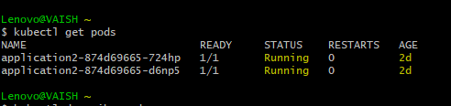

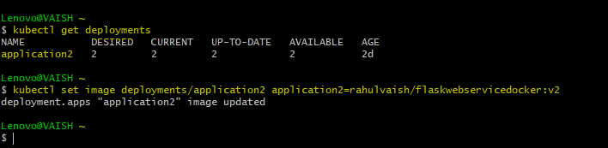

Replacing **springbootdocker** with **flaskwebservicedocker**

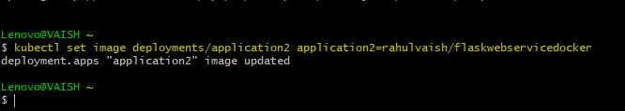

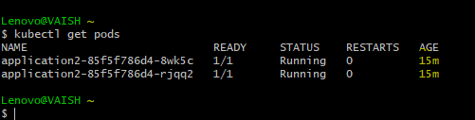

Notice 2days vs 15 minutes ☺

Checking-

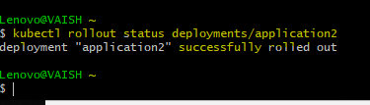

So far so good..but wait.. something looks wrong. Therefore, Rolling Back the deployment.

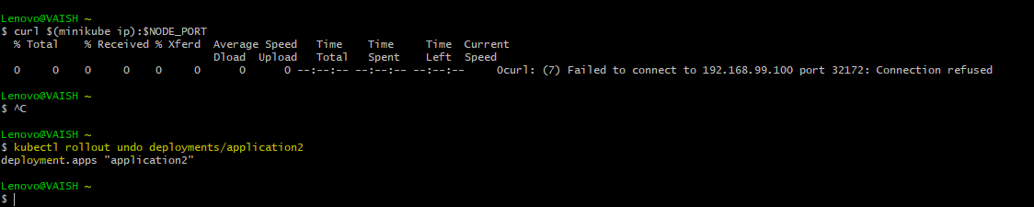

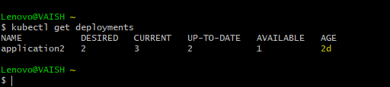

Phew !!

Let’s try updating with another image…

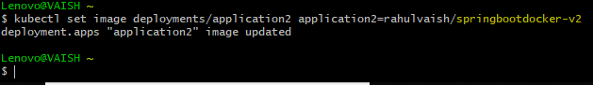

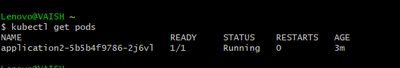

Checking..

